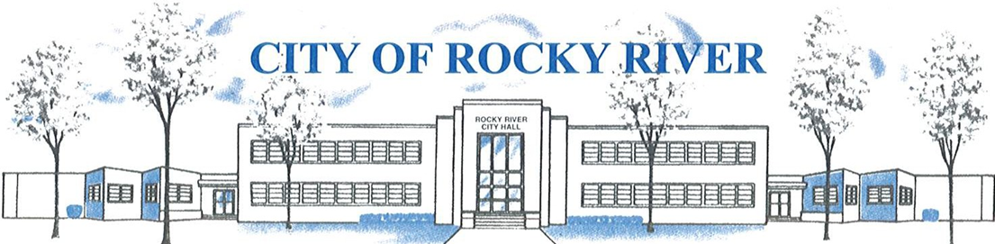
21012 HILLIARD BLVD. ROCKY RIVER, OHIO 44116 (440) 331-0600

NOTICE OF PUBLIC HEARING

BOARD OF ZONING AND BUILDING APPEALS
ON
MARCH 11, 2021

TO WHOM IT MAY CONCERN:

THE BOARD OF ZONING AND BUILDING APPEALS WILL HOLD A VIRTUAL PUBLIC HEARING VIA ZOOM (See meeting Agenda for meeting access details) ON THURSDAY, FEBRUARY 11, 2021 AT 6:00 P.M. FOR A VARIANCE TO CONSTRUCT A 2-STORY GARAGE ADDITION WITH A 53’ FRONT SETBACK (ON LAKE RD.) VS. 60’ FRONT SETBACK REQUIRED (Section 1153.07(a)); A VARIANCE TO CONSTRUCT A 2-STORY GARAGE ADDITION WITH A 7.2’ SIDE YARD SETBACK VS. 8’ SIDE YARD SETBACK REQUIRED (Section 1153.07(f)(1)A.; AND A VARIANCE TO LOCATE AN AIR CONDITIONER CONDENSER LESS THAN 10’ FROM THE SIDE PROPERTY LINE V. 10’ SIDE YARD SETBACK REQUIRED (Section 1153.15(k)) FOR BREESE AND MAGGIE WATSON, 21416 LAKE RD.

BEFORE REACHING A DECISION, THE BOARD WILL GIVE THOSE IN ATTENDANCE AN OPPORTUNITY TO BE HEARD.

PLANS SHOWING THE PROPOSED LOCATION ARE ON FILE IN THE BUILDING DIVISION OFFICE AND ARE AVAILABLE VIA E-MAIL OR FOR PICK-UP BY APPOINTMENT AT ROCKY RIVER CITY HALL, 21012 HILLIARD BOULEVARD. PLEASE CONTACT KATE STRAUB, PLANNING & ZONING COORDINATOR AT kstraub@rrcity.com OR BY CALLING 440-331-0600 EXT. 2037.

Notices sent to:
Breese and Maggie Watson Bryan and Jacqueline Selestak
Steven and Kathryn Cornelius Timothy Storch
Peter and Andrea McGannon Alexandrea Mann
John Finzer III Gregory Cada
Gregg and Holly Brokaw Brian Vigneaux
James and Patricia Seiple
Dana McCabe
John and Elizabeth Van Der Oord
Karen Drebo
Eleanor Beckwith
Owen Hood

