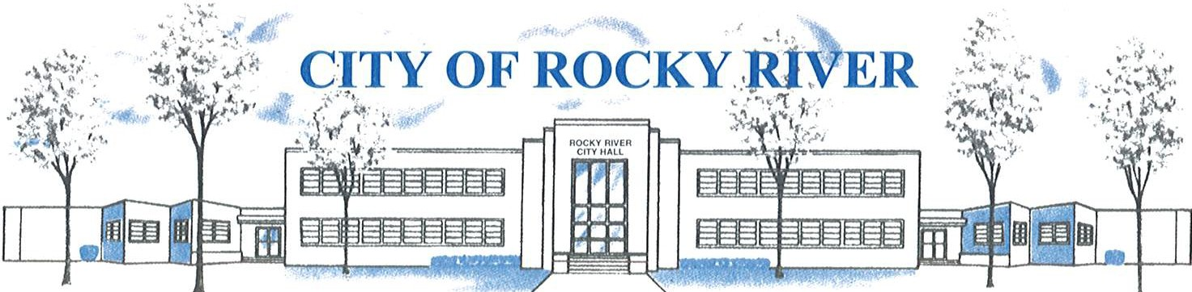
21012 HILLIARD BLVD. ROCKY RIVER, OHIO 44116 (440) 331-0600

NOTICE OF PUBLIC HEARING

BOARD OF ZONING AND BUILDING APPEALS
ON
MARCH 11, 2021

TO WHOM IT MAY CONCERN:

THE BOARD OF ZONING AND BUILDING APPEALS WILL HOLD A VIRTUAL PUBLIC HEARING VIA ZOOM (See meeting Agenda for meeting access details) ON THURSDAY, FEBRUARY 11, 2021 AT 6:00 P.M. FOR A VARIANCE TO CONSTRUCT A GARAGE ADDITION WITH A 5’ – 3” SIDE YARD SETBACK VS. 8’ SIDE YARD SETBACK REQUIRED FOR ERIN AND GARY CINTRON, 1932 WYNWOOD DR.

BEFORE REACHING A DECISION, THE BOARD WILL GIVE THOSE IN ATTENDANCE AN OPPORTUNITY TO BE HEARD.

PLANS SHOWING THE PROPOSED LOCATION ARE ON FILE IN THE BUILDING DIVISION OFFICE AND ARE AVAILABLE VIA E-MAIL OR FOR PICK-UP BY APPOINTMENT AT ROCKY RIVER CITY HALL, 21012 HILLIARD BOULEVARD. PLEASE CONTACT KATE STRAUB, PLANNING & ZONING COORDINATOR AT kstraub@rrcity.com OR BY CALLING 440-331-0600 EXT. 2037.

