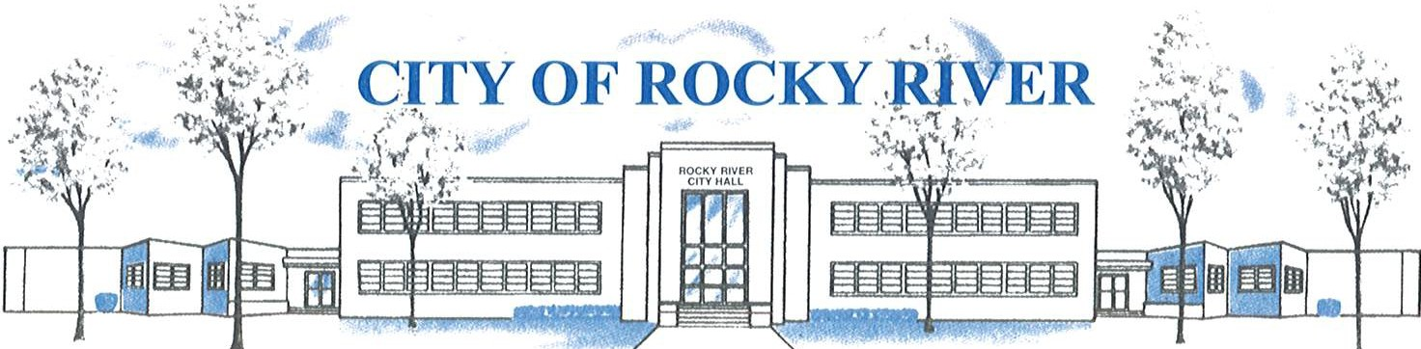
21012 HILLIARD BLVD. ROCKY RIVER, OHIO 44116 (440) 331-0600

NOTICE OF PUBLIC HEARING

BOARD OF ZONING AND BUILDING APPEALS
ON
MARCH 11, 2021

TO WHOM IT MAY CONCERN:

THE BOARD OF ZONING AND BUILDING APPEALS WILL HOLD A VIRTUAL PUBLIC HEARING VIA ZOOM (See meeting Agenda for meeting access details) ON THURSDAY, MARCH 11, 2021 AT 6:00 P.M. FOR A VARIANCE TO CONSTRUCT A DETACHED 2-CAR GARAGE WITH A 2’ SIDE YARD SETBACK VS. 5’ SIDE YARD SETBACK REQUIRED AND A VARIANCE TO CONSTRUCT A DETACHED 2-CAR GARAGE WITH A HEIGHT OF 19’ VS. 15’ MAXIMUM HEIGHT PERMITTED FOR DETACHED GARAGES FOR TIM AND KATHRYN STANTON, 1160 WAGAR RD.

BEFORE REACHING A DECISION, THE BOARD WILL GIVE THOSE IN ATTENDANCE AN OPPORTUNITY TO BE HEARD.

PLANS SHOWING THE PROPOSED LOCATION ARE ON FILE IN THE BUILDING DIVISION OFFICE AND ARE AVAILABLE VIA E-MAIL OR FOR PICK-UP BY APPOINTMENT AT ROCKY RIVER CITY HALL, 21012 HILLIARD BOULEVARD. PLEASE CONTACT KATE STRAUB, PLANNING & ZONING COORDINATOR AT kstraub@rrcity.com OR BY CALLING 440-331-0600 EXT. 2037.

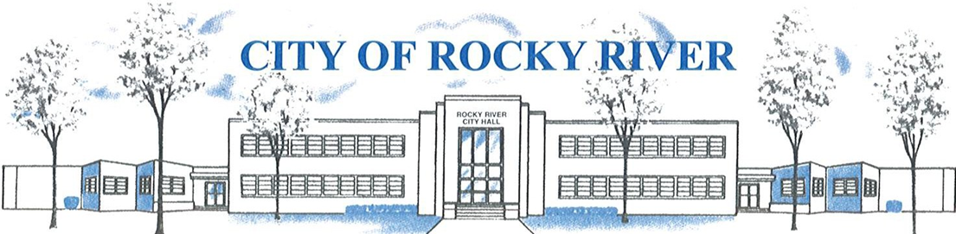
21012 HILLIARD BLVD. ROCKY RIVER, OHIO 44116 (440) 331-0600

NOTICE OF PUBLIC HEARING

BOARD OF ZONING AND BUILDING APPEALS
ON
MARCH 11, 2021

THE BOARD OF ZONING AND BUILDING APPEALS WILL HOLD A VIRTUAL PUBLIC HEARING VIA ZOOM (See meeting Agenda for meeting access details) ON THURSDAY, MARCH 11, 2021 AT 6:00 P.M. FOR A VARIANCE TO CONSTRUCT A DETACHED 2-CAR GARAGE WITH A 2’ SIDE YARD SETBACK VS. 5’ SIDE YARD SETBACK REQUIRED AND A VARIANCE TO CONSTRUCT A DETACHED 2-CAR GARAGE WITH A HEIGHT OF 19’ VS. 15’ MAXIMUM HEIGHT PERMITTED FOR DETACHED GARAGES FOR TIM AND KATHRYN STANTON, 1160 WAGAR RD.

BEFORE REACHING A DECISION, THE BOARD WILL GIVE THOSE IN ATTENDANCE AN OPPORTUNITY TO BE HEARD.

PLANS SHOWING THE PROPOSED LOCATION ARE ON FILE IN THE BUILDING DIVISION OFFICE AND ARE AVAILABLE VIA E-MAIL OR FOR PICK-UP BY APPOINTMENT AT ROCKY RIVER CITY HALL, 21012 HILLIARD BOULEVARD. PLEASE CONTACT KATE STRAUB, PLANNING & ZONING COORDINATOR AT kstraub@rrcity.com OR BY CALLING 440-331-0600 EXT. 2037.

Notices sent to:
Stanton, Timothy P Delgado, Catherine M
Coyne, Michael E & Coyne, Alison L Tobin, C G & Patricia
Moran, Kathleen M Brennan, Anci E & Ho Eric
Quinn, William Mc Dowell, Carig
Martin, Jr William F & Amer Suheir Barkley, Robert III
Pattison, Mary Grace Trustee Bemer, Andrew D Jr
Freeh, Joshua

