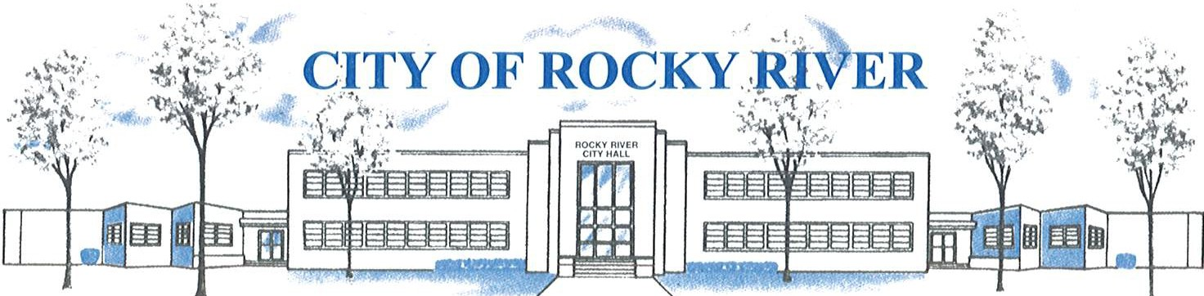

21012 HILLIARD BLVD. ROCKY RIVER, OHIO 44116 (440) 331-0600

NOTICE OF PUBLIC HEARING

BOARD OF ZONING AND BUILDING APPEALS
ON
October 17, 2024

TO WHOM IT MAY CONCERN:

THE BOARD OF ZONING AND BUILDING APPEALS WILL HOLD A PUBLIC HEARING ON THURSDAY, OCTOBER 17, 2024, AT 7:00 PM FOR A VARIANCE TO CONSTRUCT A SHED WITH A 3’ REAR AND SIDE YARD SETBACK VS. 5’ REAR AND SIDE YARD SETBACK REQUIRED (Section 1153.15 FOR 2347 WINFIELD DR.

BEFORE REACHING A DECISION, THE BOARD WILL GIVE THOSE IN ATTENDANCE AN OPPORTUNITY TO BE HEARD.

PLANS SHOWING THE PROPOSED LOCATION ARE ON FILE IN THE BUILDING DIVISION OFFICE AND ARE AVAILABLE VIA E-MAIL OR TO VIEW IN PERSON AT ROCKY RIVER CITY HALL, 21012 HILLIARD BOULEVARD. YOU MAY ALSO VIEW THE PLANS BY VISITING THE CALENDAR ON THE HOME PAGE OF THE CITY WEBSITE (www.rrcity.com) AND CLICKING ON THE MEETING LISTED FOR THIS DATE. PLEASE CONTACT KATHRYN KERBER AT KKERBER@RRCITY.COM OR BY CALLING 440-331-0600 EXT. 2598 FOR MORE INFORMATION.

