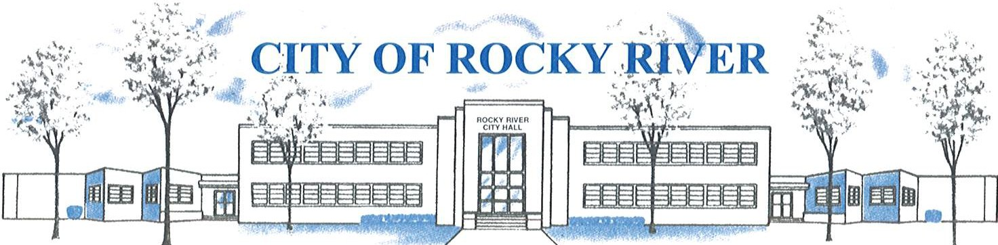
21012 HILLIARD BLVD. ROCKY RIVER, OHIO 44116 (440) 331-0600

NOTICE OF PUBLIC HEARING

BOARD OF ZONING AND BUILDING APPEALS
ON
NOVEMBER 21, 2024

TO WHOM IT MAY CONCERN:

THE BOARD OF ZONING AND BUILDING APPEALS WILL HOLD A PUBLIC HEARING ON THURSDAY, NOVEMBER 21, 2024, AT 7:00 PM FOR A VARIANCE TO CONSTRUCT A PARKING SPOT WITH A 10’ WIDTH VS. 8’ AS REQUIRED PER SECTION: 1153.15 (L)(4)(B) AND A VARIANCE TO CONSTRUCT ANACCESSORY PARKING SPOT WITH A 12’ SETBACK VS. 35’ AS REQUIRED PER SECTION ; 1153.15 (L)(4)(B) FOR JOHN & MEGAN ZARLENGA, 20511 MOREWOOD PKWY.

BEFORE REACHING A DECISION, THE BOARD WILL GIVE THOSE IN ATTENDANCE AN OPPORTUNITY TO BE HEARD.

PLANS SHOWING THE PROPOSED LOCATION ARE ON FILE IN THE BUILDING DIVISION OFFICE AND ARE AVAILABLE FOR REVIEW VIA E-MAIL OR IN-PERSON AT ROCKY RIVER CITY HALL, 21012 HILLIARD BOULEVARD. PLEASE CONTACT KATHRYN KERBER AT KKERBER@RRCITY.COM OR BY CALLING 440-331-0600 EXT. 2598.

Notices sent to:
See attached list

