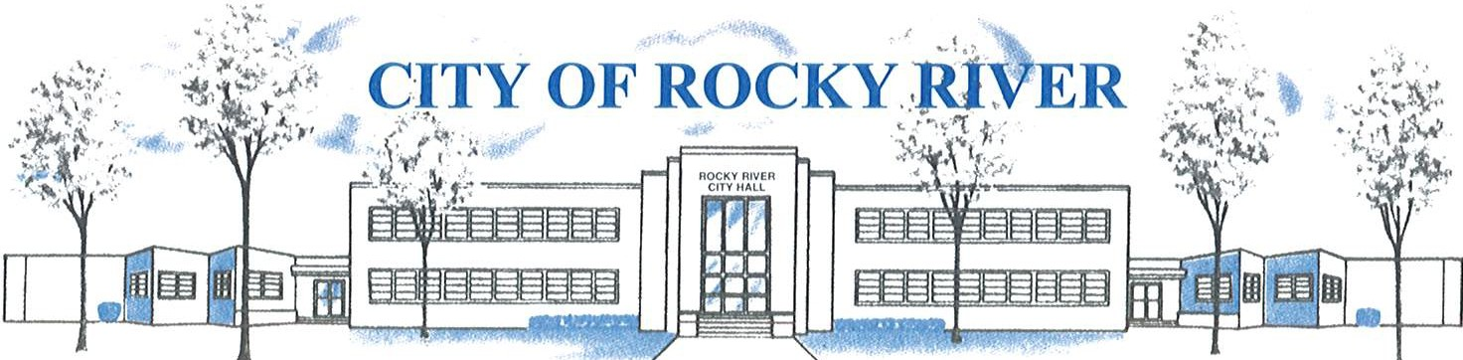
21012 HILLIARD BLVD. ROCKY RIVER, OHIO 44116 (440) 331-0600

NOTICE OF PUBLIC HEARING

BOARD OF ZONING AND BUILDING APPEALS
ON
December 12, 2024

TO WHOM IT MAY CONCERN:

THE BOARD OF ZONING AND BUILDING APPEALS WILL HOLD A PUBLIC HEARING ON December 12, 2024, AT 7:00 PM FOR A VARIANCE TO CONSTRUCT AN ACCESSORY STORAGE BUILDING WITH A FLOOR AREA OF 160 SQ. FT. VS. A FLOOR AREA OF 120 SQ.FT. PERMITTED AS REQUIRED PER SECTION: 1153.15(c) AND A VARIANCE TO CONSTRUCT AN ACCESSORY STORAGE BUILDING WITH A HEIGHT OF 11’6” VS. A 10’ PERMITTED HEIGHT PER SECTION: 1153.09(b).
FOR THEODORE KUHNEN AT 2854 GOLDWOOD AVE.

BEFORE REACHING A DECISION, THE BOARD WILL GIVE THOSE IN ATTENDANCE AN OPPORTUNITY TO BE HEARD.

PLANS SHOWING THE PROPOSED LOCATION ARE ON FILE IN THE BUILDING DIVISION OFFICE AND ARE AVAILABLE FOR REVIEW VIA E-MAIL OR IN-PERSON AT ROCKY RIVER CITY HALL, 21012 HILLIARD BOULEVARD. PLEASE CONTACT KATHRYN KERBER AT KKERBER@RRCITY.COM OR BY CALLING 440-331-0600 EXT. 2598.

Notices sent to:
See attached list

Per section: 1153.09(B).

