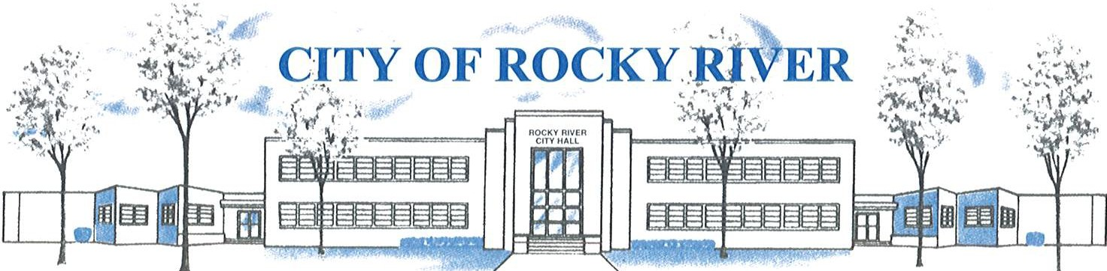
21012 HILLIARD BLVD. ROCKY RIVER, OHIO 44116 (440) 331-0600

NOTICE OF PUBLIC HEARING

Board of Zoning and Building Appeals

January 9, 2025

Regarding: Dan Brogan, 19500 Beachcliff

To Whom It May Concern:

The Board of Zoning and Building Appeals will hold a public hearing on January 9, 2025, at 7:00 pm for a variance to place an accessory generator with a side yard setback of five (5) feet vs. ten (10) feet permitted as required per section: 1153.15 (k)(2).

Before reaching a decision, the Board will give those in attendance an opportunity to be heard.

Plans showing the proposed location are available:
- Online at www.rrcity.com under “City Meeting Central”
- On file in the Building Department at Rocky River City Hall, 21012 Hilliard Blvd.
- By email by contacting Kathryn Kerber at kkerber@rrcity.com or calling 440-895-2598.

Sincerely.

Department of Planning and Community Development
The City of Rocky River

