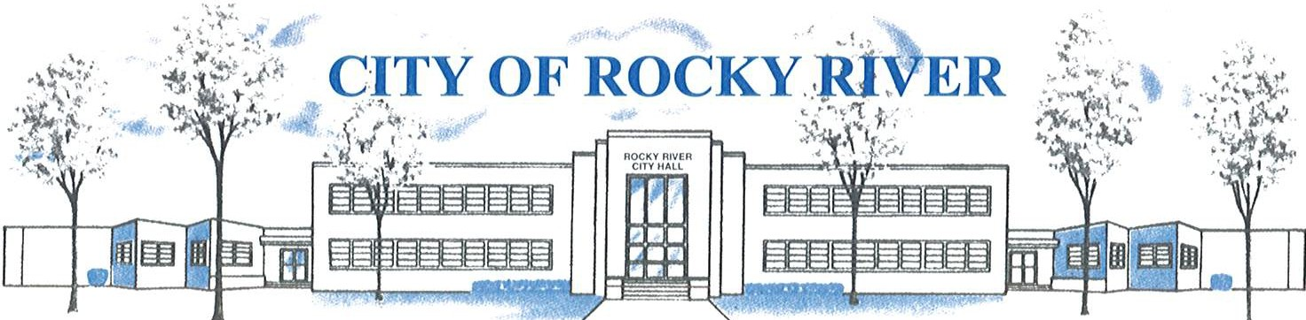
21012 HILLIARD BLVD. ROCKY RIVER, OHIO 44116 (440) 331-0600

NOTICE OF PUBLIC HEARING

BOARD OF ZONING AND BUILDING APPEALS
ON
January 9, 2025

TO WHOM IT MAY CONCERN:

THE BOARD OF ZONING AND BUILDING APPEALS WILL HOLD A PUBLIC HEARING ON JANUARY 9, 2025, AT 7:00 PM FOR A VARIANCE TO PLACE AN ACCESSORY GENERATOR WITH A SIDE YARD SETBACK OF FIVE (5) FEET VS. TEN (10) FEET PERMITTED AS REQUIRED PER SECTION: 1153.15 (k)(2).
FOR DAN BROGAN AT 19550 BEACHCLIFF.

BEFORE REACHING A DECISION, THE BOARD WILL GIVE THOSE IN ATTENDANCE AN OPPORTUNITY TO BE HEARD.

PLANS SHOWING THE PROPOSED LOCATION ARE ON FILE IN THE BUILDING DIVISION OFFICE AND ARE AVAILABLE FOR REVIEW VIA E-MAIL OR IN-PERSON AT ROCKY RIVER CITY HALL, 21012 HILLIARD BOULEVARD. PLEASE CONTACT KATHRYN KERBER AT KKERBER@RRCITY.COM OR BY CALLING 440-331-0600 EXT. 2598.

Notices sent to:
See attached list

