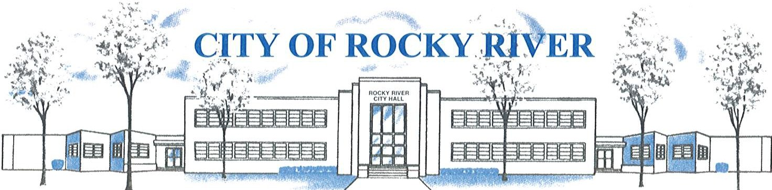
21012 HILLIARD BLVD. ROCKY RIVER, OHIO 44116 (440) 331-0600

NOTICE OF PUBLIC HEARING

BOARD OF ZONING AND BUILDING APPEALS
ON
January 9, 2025

TO WHOM IT MAY CONCERN:

THE BOARD OF ZONING AND BUILDING APPEALS WILL HOLD A PUBLIC HEARING ON JANUARY 9, 2025, AT 7:00 PM FOR A VARIANCE TO CONSTRUCT SIXTY (60) FEET OF FIVE (5) FOOT SOLID FENCING AND SEVENTY-TWO (72) FEET OF FOUR (4) FOOT SOLID FENCING VS. fences that are twenty-five percent (25%) transparent regardless of the angle at which the transparency is viewed are the only types of fences permitted in the rear yard PERMITTED AS REQUIRED PER SECTION: 1153.15 (J)(3) & 1153.15(J)(2).
FOR MICHAEL & SHARON SPOONER AT 20354 WESTHAVEN.

BEFORE REACHING A DECISION, THE BOARD WILL GIVE THOSE IN ATTENDANCE AN OPPORTUNITY TO BE HEARD.

PLANS SHOWING THE PROPOSED LOCATION ARE ON FILE IN THE BUILDING DIVISION OFFICE AND ARE AVAILABLE FOR REVIEW VIA E-MAIL OR IN-PERSON AT ROCKY RIVER CITY HALL, 21012 HILLIARD BOULEVARD. PLEASE CONTACT KATHRYN KERBER AT KKERBER@RRCITY.COM OR BY CALLING 440-331-0600 EXT. 2598.

Notices sent to:
See attached list

