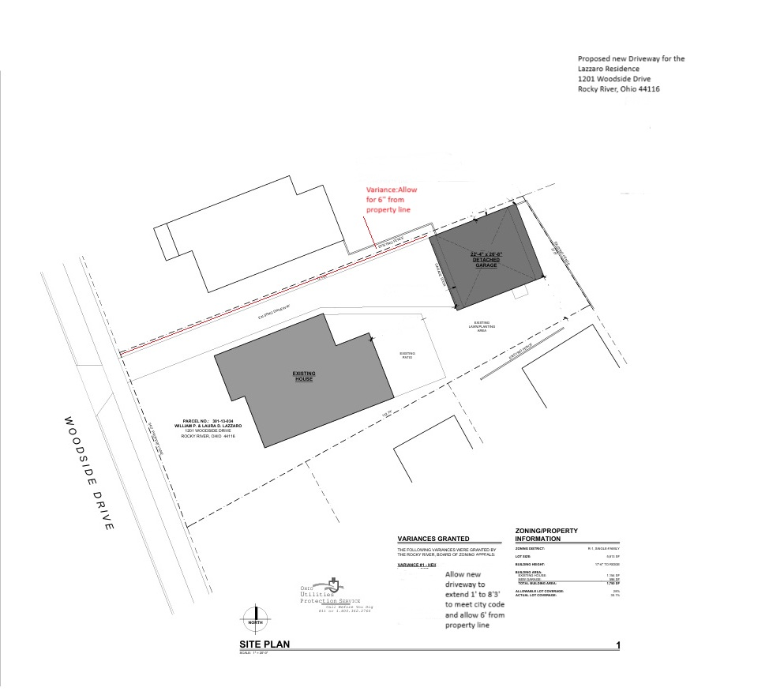
Proposed new Driveway for the Lazzaro Residence
1201 Woodside Drive
Rocky River Ohio, 44116

Variance Request: Allow new driveway to extend 1’ to 8’3” to meet city code and allow for 6’ from the property line. The Red Line represents the variance request.

