Amy & Nanci Emig Rear Dormer Project
1524 Hampton, Rocky River

Front View of Subject Residence
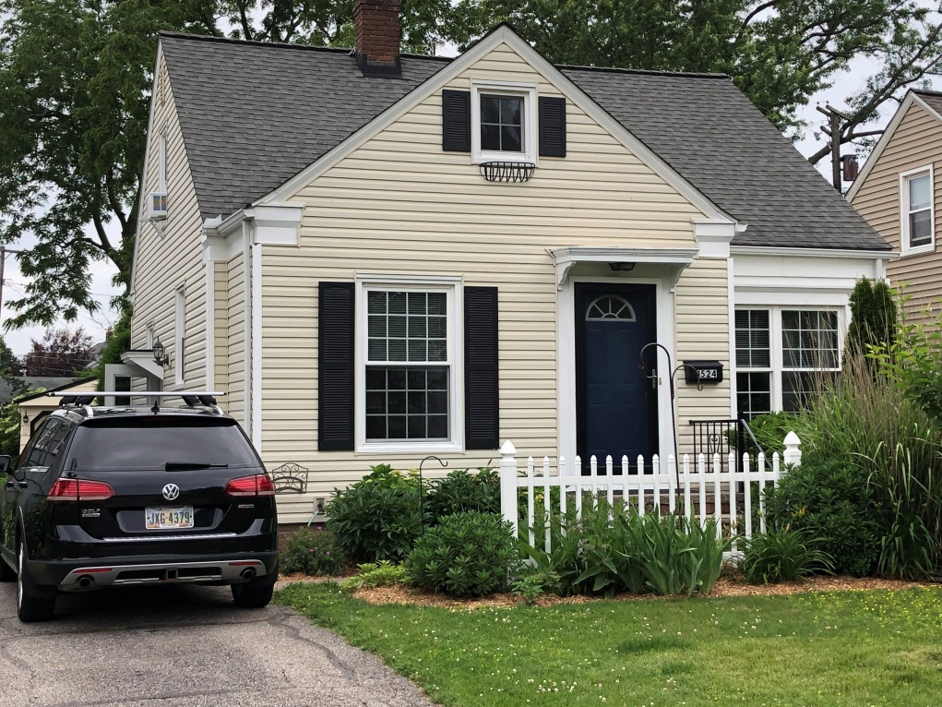

Rear View of Subject Residence (where dormer will be built)
