Amy & Nanci Emig Rear Dormer Project
1524 Hampton, Rocky River
Neighbor’s Residence to North
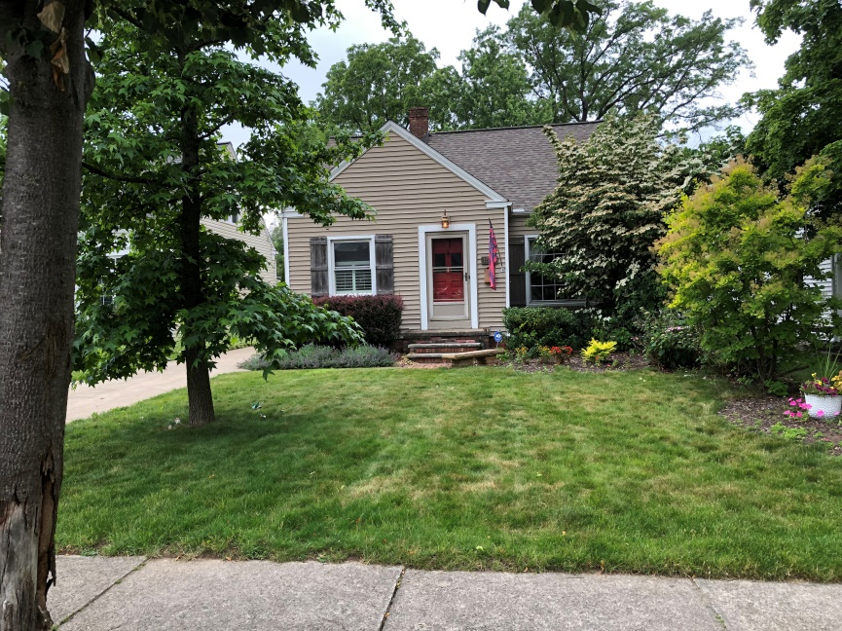

Rear of Neighbor’s Residence to North (This is the identical shed dormer to be constructed)
