Amy & Nanci Emig Rear Dormer Project
1524 Hampton, Rocky River

South Facing Side of Subject Residence
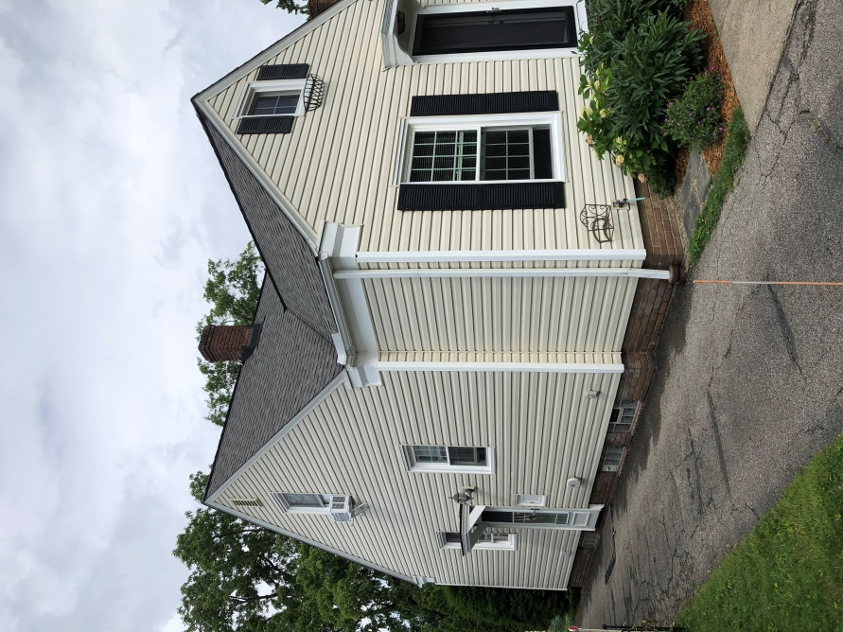

North Facing Side of Subject Residence
