Example Images
2666 Wagar Road, Rocky River, Ohio 44116
Halle Buescher

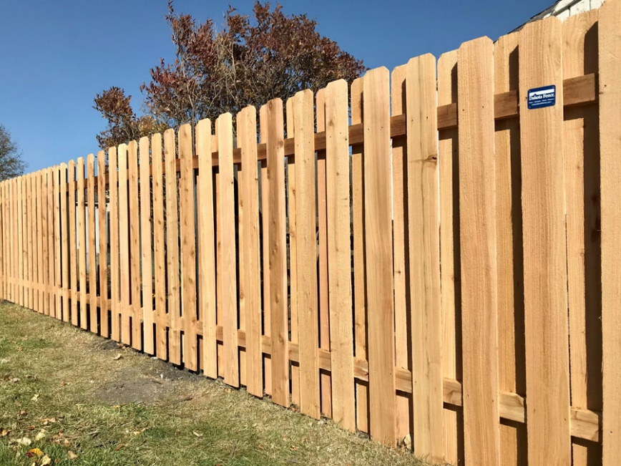
Figure 1. Wood Fence – Example 1

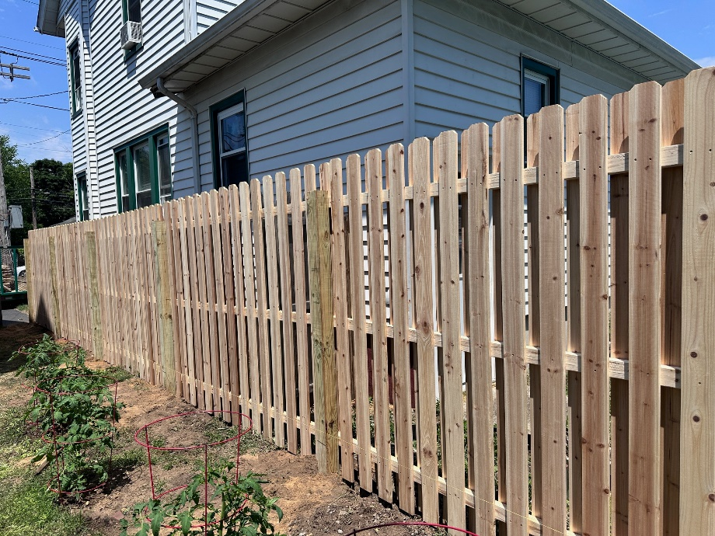
Figure 2. Wood Fence – Example 2

