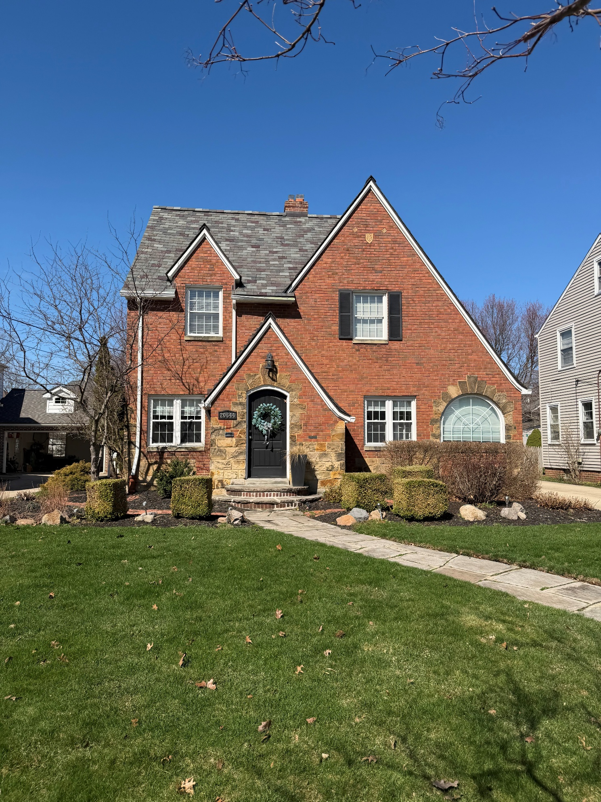
20644 Stratford Ave – Across the street (northeast side)
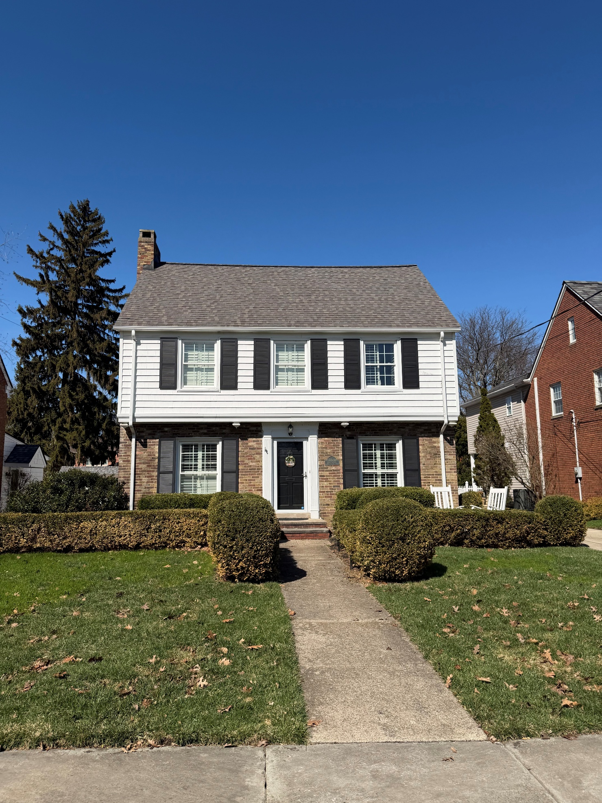
20660 Stratford Ave – Directly across the street
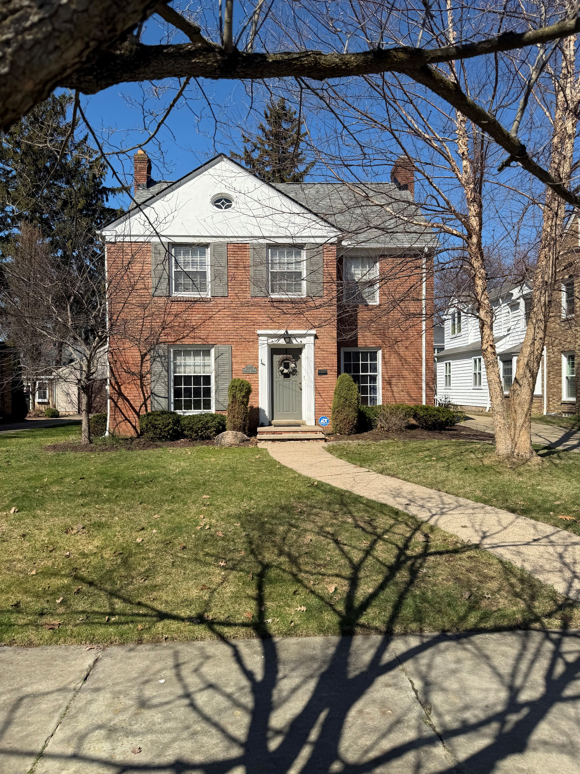
20672 Stratford Ave – Neighbor across the street (northwest)
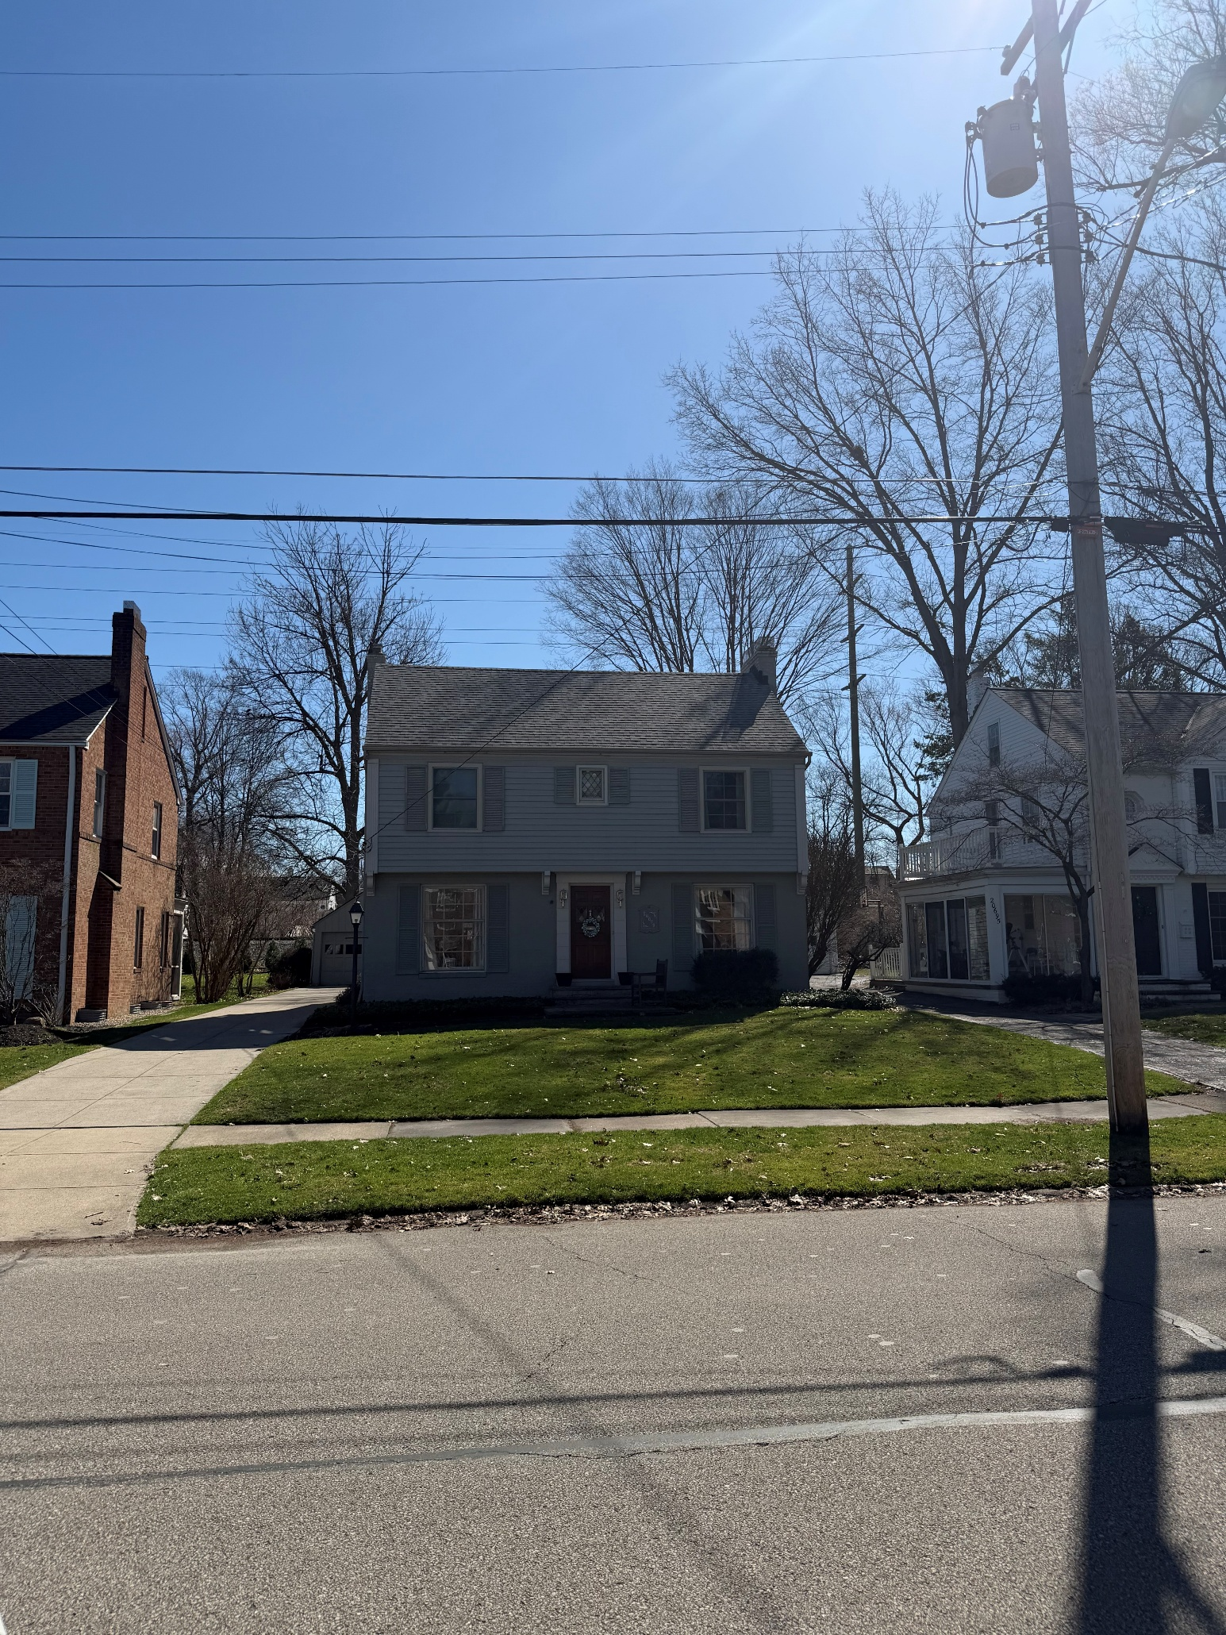
20679 Stratford Ave – Neighbor to the west
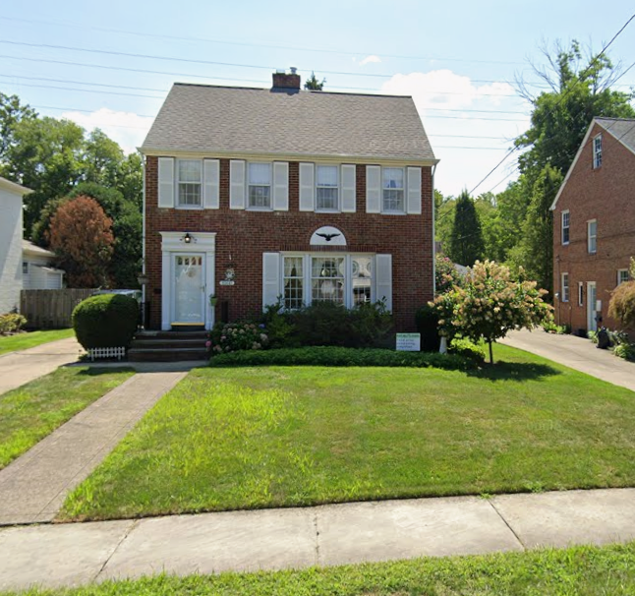
20647 Stratford Ave – Neighbor to the east
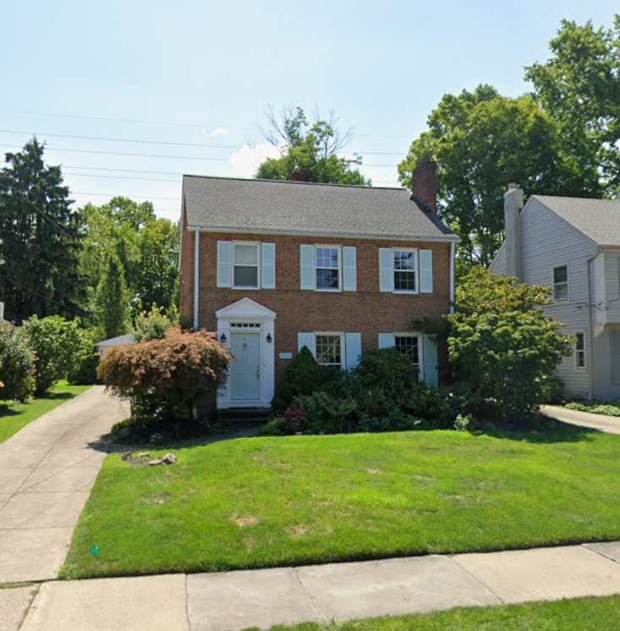
20663 Stratford Ave – Subject property

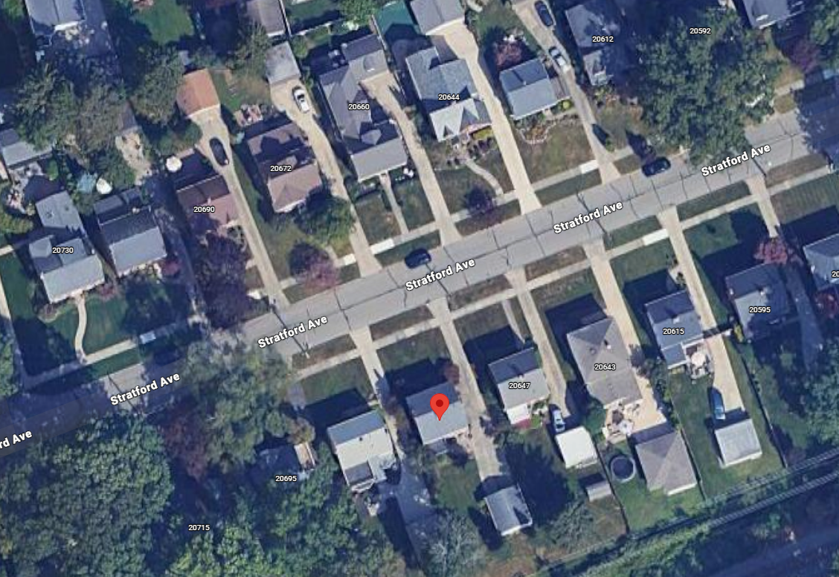
Aerial map

