Here are two different color versions for the alternate look which is a flat instead of a lap.
In either color choice, the aluminum will be painted to match, just like many neighbors have painted their brick or stone to match something else.
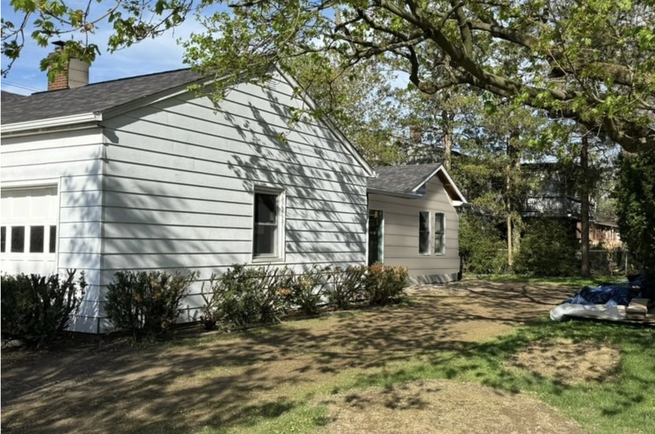

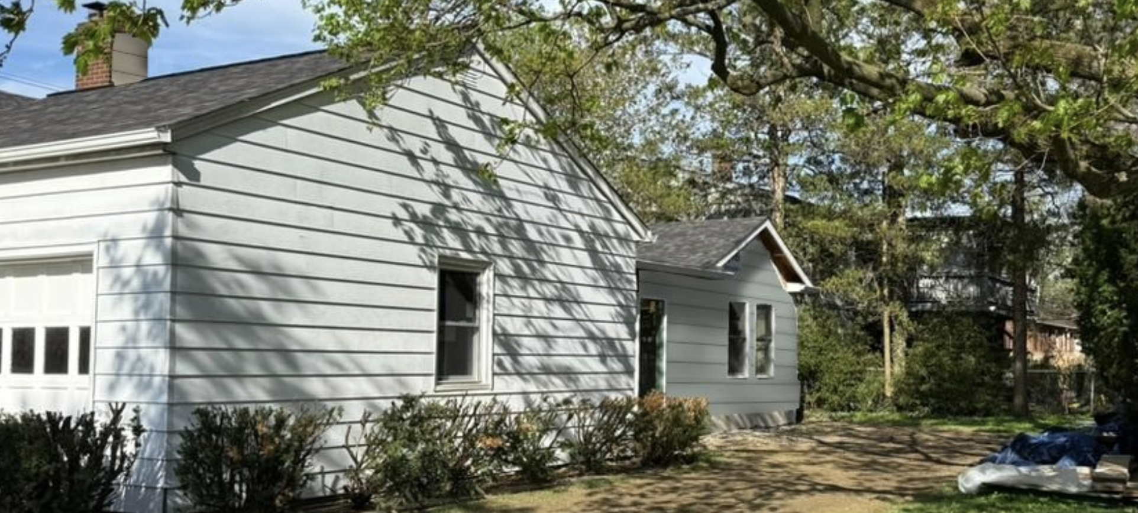

Below is the product I am trying to get in Natural Clay. I will have a color chip .
CERTAplank® | CertainTeed

CERTAplank® | CertainTeed

My contractor found an alternate product, here is the link. also a 7 in vinyl and it has the woodgrain
Color & Design - Ascend

Color & Design - Ascend
ASCEND colors and profiles are chosen to reflect today's home trends and can easily be used in any size of project.

