Rose & Moises Buzon
3130 Spencer, Rocky River
Street view of neighbor to the North
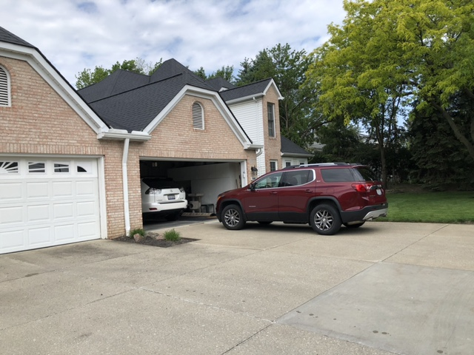

Street view of Buzon Property
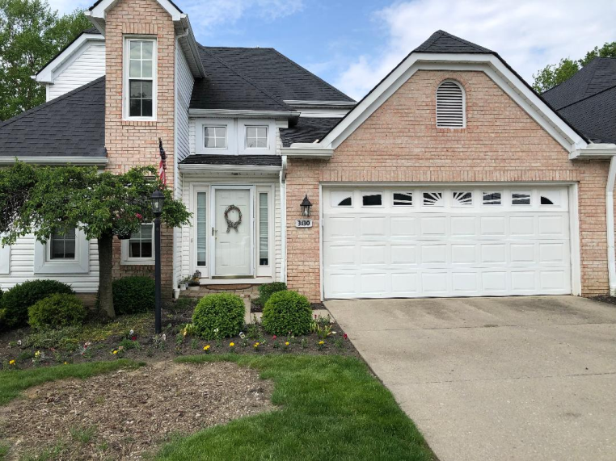

Rear view of neighbor’s back yard to the North
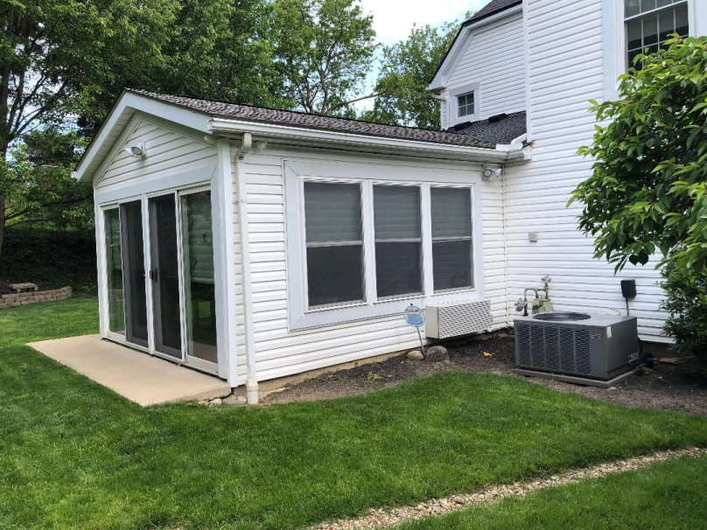

Rear view of Buzon’s existing 3-Season Room
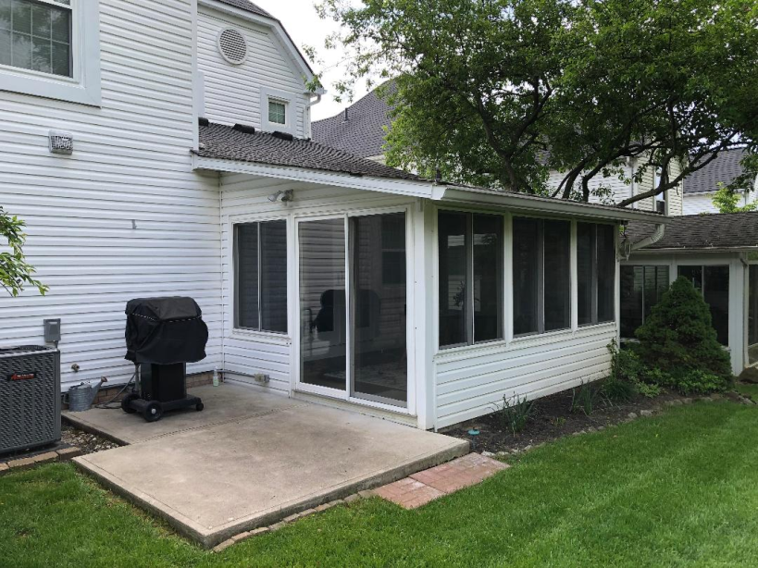

Rear view of neighbor’s back yard to the South
